**Tutorial 14: Passing Data with Props**

When we want to pass data from the parent component to the child components we will use props. It makes components more reusable and we do not have to hard code all the data and content into the code. Each time you reuse the component, you can pass different data and content into it as a prop from it’s parent component. If we have multiple components and they all use the same data whether that be text or an array of items or something else, it means that we only have to define that data in one single place.

Make sure **Tutorial 13** is complete to be able to move on to this tutorial or clone the [vue3-firebase-course](https://github.com/younggrasshopperza/vue3-firebase-course) repository and go to branch called **Tutorial-13**.

**Step 1:** In the **App.vue** file, in the template in the **Modal** component being called create an attribute called header and pass the text “**Sign up to win a prize!**”.

Look at the example below (**Line 3**):

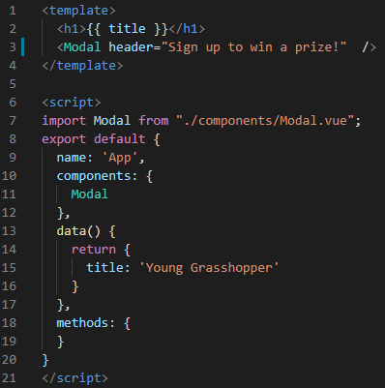

In the **Modal.vue** file, create a script tag, export an object in the script and add the props value with an array that takes a string value called header which is the value that we will be accepting into the component.

Look at the example below (**Line 4 and Line 11**):

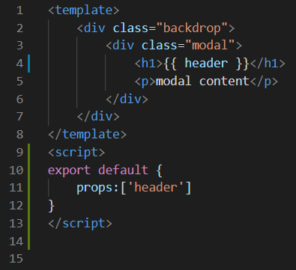

**Output:**

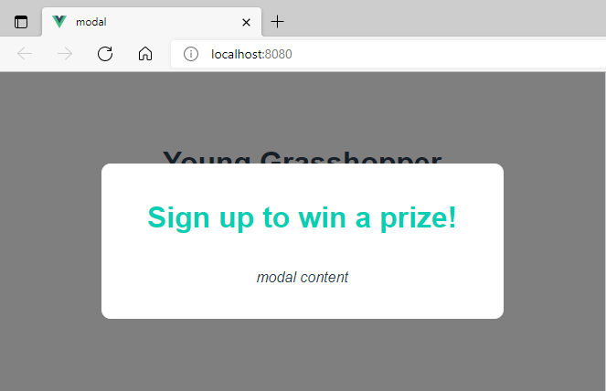

**Step 2:** In the App.vue file, in the template in the **Modal** component being called create an attribute called text and pass the text “**Come get your 50% discount now whilst stock last!**”.

Look at the example below (**Line 3**):

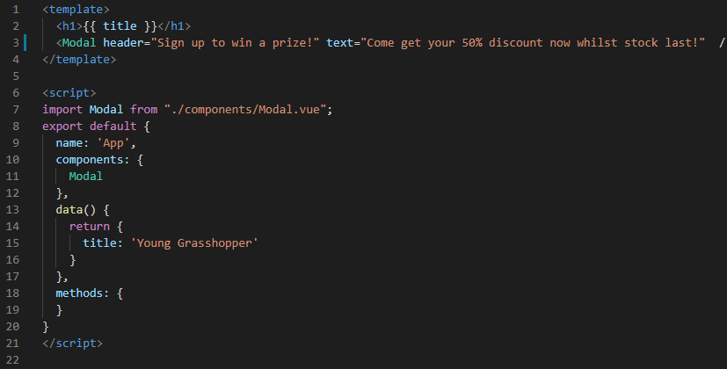

In the **Modal.vue** file, add to the props a string value called text which is the value that we will be accepting into the component.

Look at the example below (**Line 4 and Line 11**):

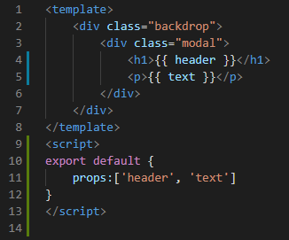

**Output:**

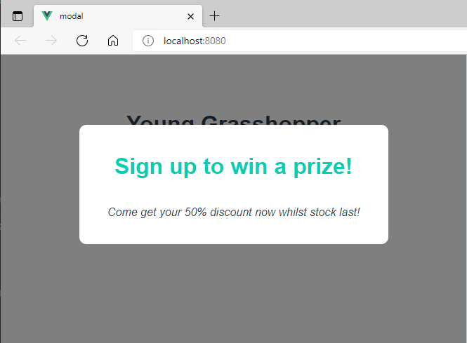

**Step 3:** In the file App.vue, bind the prop with the data property rather than direcrtly putting the text inside the component.

Look at the example below (**Line 3 and between Line 16 to 17**):

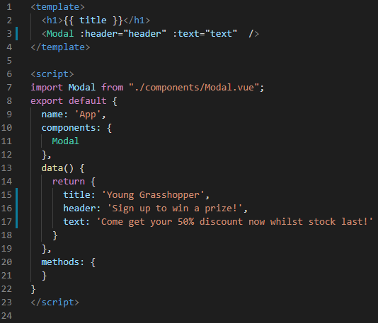

**Step 3:** In the file **App.vue**, create a prop called theme that takes a value called promotion.

Look at the example below (**Line 3**):

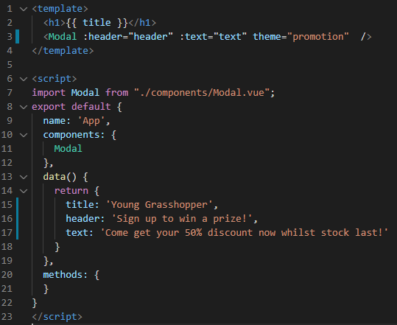

In the file **Modal.vue**, add a binding class that checks whether the prop, theme, has the value promotion.

Look at the example below (**Line 3 and Line 11**):

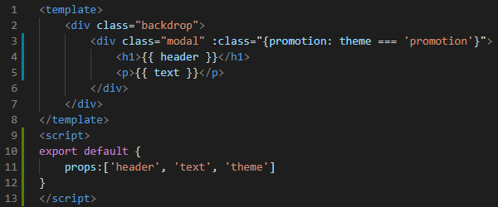

In the file **Modal.vue**, add the following CSS code below:

.modal.promotion {

    background: crimson;

    color: white;

}

.modal.promotion h1 {

    color: white;

}

Look at the example below (**Between** **Line 35 and Line 41**):

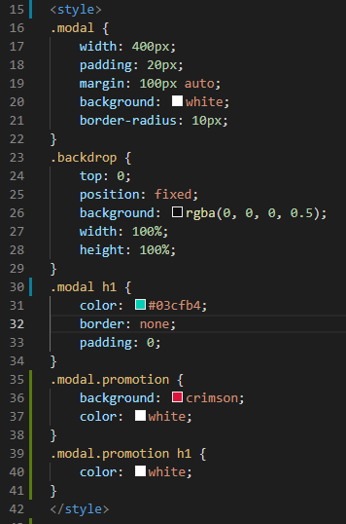

**You can view the code snippets from the** [**vue3-firebase-course**](https://github.com/younggrasshopperza/vue3-firebase-course) **repository under the Tutorial-14 branch.**